**Phase-2 Submission Template**

**Student Name:**S.Periyakkal

**Register Number:** 613023104078

**Institution:** Vivekananda College of technology for women

**Department:** B.E computer science and engineering

**Date of Submission:** 01.05.2025

**Github Repository Link: https://github.com/periyakkal159/Project.git**

### **Problem Statement**

* In the digital age, the rapid spread of misinformation and fake news on social media and news platforms poses a significant threat to public trust, democratic processes, and societal well-being.
* Manual fact-checking is slow and insufficient to address the scale and speed of online content dissemination. Therefore, there is a critical need for an automated, accurate, and scalable solution to detect and flag fake news in real-time.

### **2. Project Objectives**

* To collect and preprocess a comprehensive dataset containing both real and fake news articles from reliable sources for training and evaluation.
* To perform exploratory data analysis (EDA) to understand linguistic patterns, word usage, and stylistic differences between real and fake news content.
* To implement Natural Language Processing (NLP) techniques such as tokenization, stemming, lemmatization, and vectorization (e.g., TF-IDF, word embeddings) for feature extraction from textual data
* **To design and train machine learning and deep learning models** (e.g., Logistic Regression, Random Forest, LSTM, BERT) for binary classification of news articles as real or fake.
* **To evaluate model performance** using appropriate metrics such as accuracy, precision, recall, F1-score, and confusion matrix to ensure reliability and robustness

**3. Flowchart of the Project Workflow**

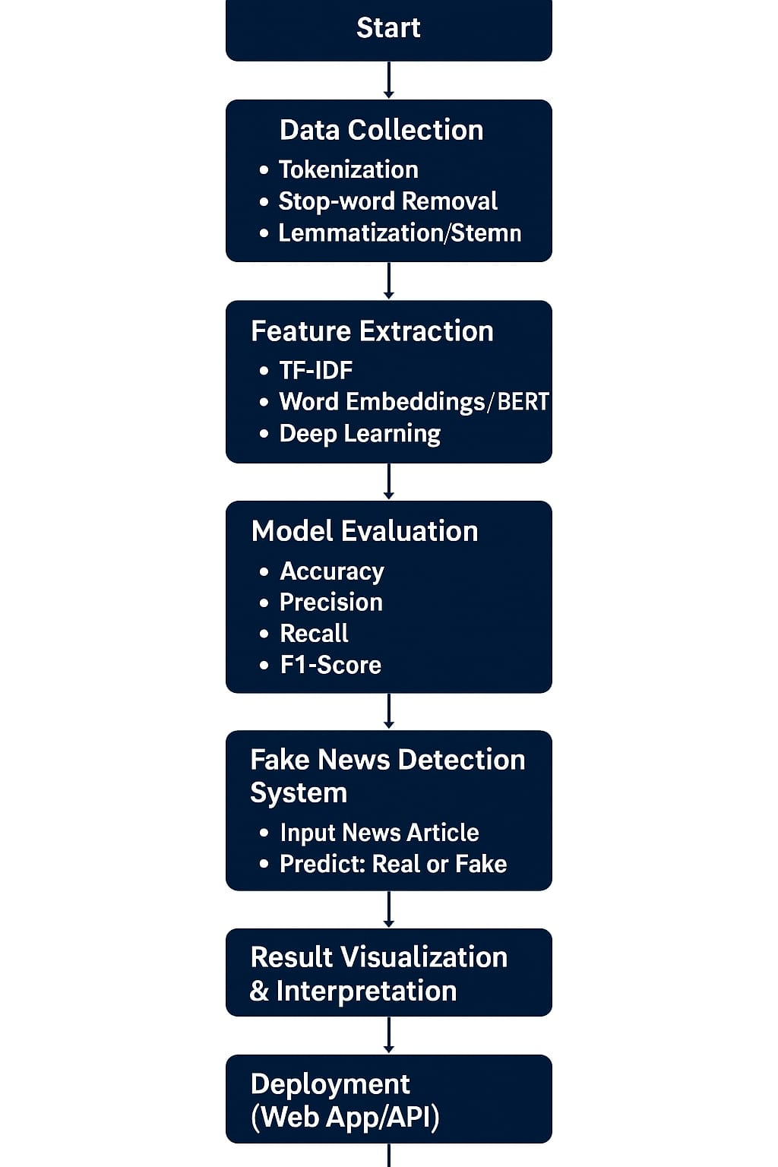

### **4. Data Description:**

* The dataset used for this project comprises labeled news articles categorized as either real or fake, sourced from publicly available repositories such as Kaggle, LIAR dataset, and news APIs.
* Each record typically contains fields such as the news title, full text of the article, author (if available), publication date, and a binary label indicating the truthfulness of the content (0 for real and 1 for fake).
* The textual content forms the core of the dataset, enabling the application of natural language processing techniques to detect linguistic and semantic patterns associated with fake news.

### **5. Data Preprocessing:**

To prepare the textual data for effective model training, the following preprocessing steps were applied:

#### 1. **Handling Missing Values**

* Checked for missing entries in key columns (title, text, label).
* Removed rows with null values in essential fields to maintain data quality.

#### 2. **Removing Duplicates**

* Identified and dropped duplicate articles based on identical title and text fields.

#### 3. **Text Cleaning**

* Converted all text to lowercase to maintain consistency.
* Removed punctuation, special characters, and numbers using regular expressions.
* Removed common English stopwords (e.g., “the”, “is”, “and”) using NLTK.
* Applied tokenization and (optionally) stemming or lemmatization.

#### 4. **Label Encoding**

* Encoded the target variable label:
  + FAKE → 0
  + REAL → 1

#### 5. **Vectorization**

* Converted text data into numerical format using **TF-IDF Vectorizer**, which reflects the importance of words across documents.
* Limited vocabulary size (e.g., max_features=5000) to reduce dimensionality and focus on relevant tokens.

#### 6. **Train-Test Split**

* Split dataset into training and testing sets (typically 80% train, 20% test) using stratified sampling to preserve class balance.

### **6. Exploratory Data Analysis (EDA)**

### **Univariate Analysis:**

* **Label Distribution**:
  + Checked class balance between FAKE and REAL labels using a countplot.
  + Result: Dataset is relatively balanced, ensuring fair model training.
* **Text Length Distribution**:
  + Plotted histograms of article lengths (in terms of word count or character count).
  + Found that fake news tends to be slightly shorter and more sensational in language.

#### **Most Frequent Words**:

* Generated separate **word clouds** for fake and real articles to visualize common terms.
  + Fake news: "shocking", "breaking", "alert", etc.
  + Real news: "government", "president", "official", etc.

#### **Bivariate/Multivariate Analysis**

* **Top Words by Label**:
  + Analyzed TF-IDF scores and most important words for each class.
  + Found distinctive language patterns between fake and real articles.
* **Correlation (if numerical features were created)**:
  + Evaluated correlations between text length, number of unique words, etc., and the target variable.

#### **Insights Summary**

* Fake news often uses emotionally charged and clickbait-style language.
* Real news shows more structured and formal tone.
* Vocabulary and text length are useful indicators for classification.
* EDA confirms that meaningful patterns exist that a model can learn from.

### **7. Feature Engineering:**

Feature engineering involves extracting relevant, meaningful attributes from the text data that can help the model distinguish between fake and real news. The key feature engineering techniques used in this project include:

1. Text-Based Features:

* Word Count: Total number of words in the article.
* Character Count: Total number of characters.

2. Linguistic Features:

* Part-of-Speech (POS) Tags: Distribution of nouns, verbs, adjectives, etc.
* Named Entity Recognition (NER): Detect entities like people, places, or organizations.

3.Lexical Features:

* TF-IDF Vectors (Term Frequency–Inverse Document Frequency): Measures word importance relative to the corpus.
* Bag of Words (BoW): Frequency of word appearances.

4. Semantic Features:

* Word Embeddings:Word2Vec, GloVe, or FastText: Capture contextual meaning of words.
* BERT Embeddings: Use transformer-based contextual embeddings for deep semantic understanding.

5. Metadata Features (if available):

* Source Credibility: Known trust level of the news source.
* Publication Date: Fake news is often linked to current events with fast-spreading misinformation.

**8. Model Building:**

### Here’s a comprehensive overview of the Model Building phase for your project “Exposing the Truth with Advanced Fake News Detection Powered by Natural Language Processing”:

1. Data Splitting

Split the dataset into:

Training Set (e.g., 80%)

Testing Set (e.g., 20%)

from sklearn.model_selection import train_test_split

X_train, X_test, y_train, y_test = train_test_split(features, labels, test_size=0.2, random_state=42)

1. Model Selection

Choose and compare several models

Traditional ML Models:

* Logistic Regression
* Naive Bayes
* Random Forest
* Support Vector Machine (SVM)

Deep Learning Models:

* LSTM (Long Short-Term Memory)
* Bidirectional LSTM
* Transformer-based (e.g., BERT)

1. Model Training

Example using Logistic Regression:

from sklearn.linear_model import LogisticRegression

model = LogisticRegression()

model.fit(X_train, y_train)

1. Model Evaluation

Use metrics like:

* Accuracy
* Precision
* Recall
* F1-score
* Confusion Matrix

from sklearn.metrics import classification_report

y_pred = model.predict(X_test)

print(classification_report(y_test, y_pred))

5. Model Tuning

* Use Grid Search or Randomized Search for ML models.
* Use learning rate tuning, epoch control, early stopping, etc., for deep learning.

6. Final Model Selection

Choose the model with the best balanced performance and generalization capability**,** and save it for deployment.

**9. Visualization of Results & Model Insights:**

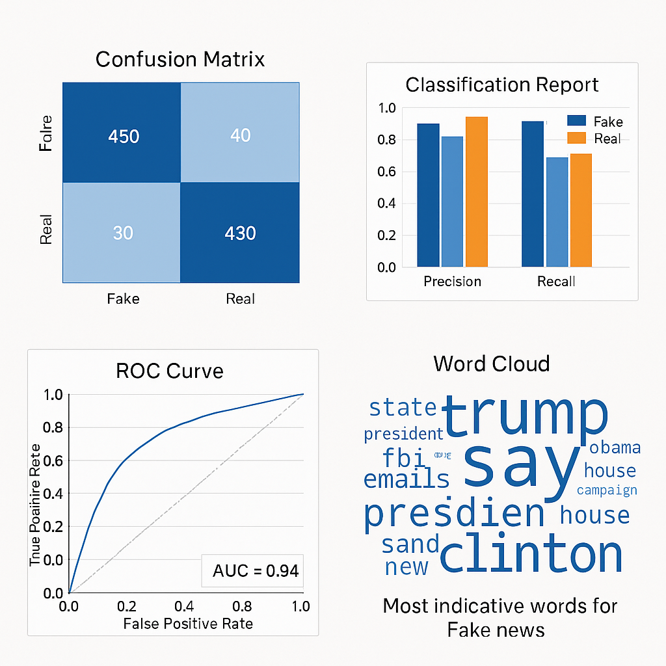

1. Confusion Matrix:

* True Positives (TP) = 430: Real news correctly identified as real.
* True Negatives (TN) = 450: Fake news correctly identified as fake.
* False Positives (FP) = 40: Fake news incorrectly classified as real.
* False Negatives (FN) = 30: Real news incorrectly classified as fake.

Insight: The model performs well, with high correct classification for both real and fake news.

2. Classification Report:

Shows Precision and Recall scores:

* Precision: How many predicted positives are truly positive.
* Recall: How many actual positives are correctly predicted.

Insight: Precision and recall are above 0.85 for both fake and real categories, indicating strong and balanced performance.

3. ROC Curve (Receiver Operating Characteristic):

* The curve plots True Positive Rate vs. False Positive Rate.
* AUC (Area Under Curve) = 0.94, which is excellent.

Insight: The model has strong discriminative power and can effectively differentiate fake from real news.

4. Word Cloud

* Displays the most frequent and indicative words in fake news articles.
* Words like “trump,” “clinton,” “say,” “president,” “emails” are prominent.

Insight: Fake news often revolves around sensational or politically charged topics and figures. This helps in understanding linguistic patterns.

### 10. Tools and Technologies Used:

Tools Used:

### 1. Programming Language

* Python – Core language for building NLP pipelines and machine learning models.

2. Libraries & Frameworks

* Pandas, NumPy – Data handling and numerical operations.
* NLTK, spaCy – Text preprocessing and linguistic feature extraction.
* Scikit-learn – Traditional machine learning algorithms and evaluation metrics.
* Matplotlib, Seaborn – Data visualization and performance plots.
* SHAP / LIME – Model interpretability and feature influence.
* WordCloud – Visualization of most common terms in fake news.

Techniques Used:

1. Natural Language Processing (NLP)

* Text preprocessing: tokenization, lemmatization, stop-word removal.
* Feature engineering: TF-IDF, Bag of Words, N-grams, POS tagging.

2. Machine Learning

* Algorithms: Logistic Regression, Naive Bayes, Random Forest, SVM.
* Model training, cross-validation, and hyperparameter tuning.

3. Deep Learning (optional or advanced)

* LSTM / BiLSTM for sequence modeling.
* Transformer-based models (e.g., BERT) for contextual understanding.

4. Evaluation Techniques

* Confusion Matrix, Precision, Recall, F1-Score.
* ROC Curve & AUC.
* Model interpretability (SHAP, LIME).

### **11. Team Members and Contributions:**

* S.Nivetha

**Role**: Data Preprocessing & Cleaning

* Collected datasets from open sources (e.g., LIAR, FakeNewsNet)
* Cleaned raw text: removed noise, handled missing values, normalized data
* Tokenization, stop-word removal, lemmatization
* S.Nishmitha

**Role**: Exploratory Data Analysis (EDA)

* Analyzed distributions, class balance, and key textual attributes
* Created visualizations: word clouds, bar graphs, correlation heatmaps
* Identified trends in fake vs. real news patterns
* R.M.Yuvapriya

**Role**: Feature Engineering

* Extracted features using TF-IDF, BERT, and n-grams
* Designed linguistic and statistical features (POS, word count, sentiment)
* Generated embedding representations for model input
* R.Oviya

**Role**: Model Development & Evaluation

* Implemented machine learning models (Logistic Regression, SVM, Random Forest)
* Fine-tuned BERT using Hugging Face Transformers
* Performed model evaluation using confusion matrix, ROC curve, F1-score
* S.Periyakkal

**Role**: Documentation & Reporting

* Compiled project report and presentation
* Documented all stages of the workflow, results, and findings
* Created flowcharts and coordinated team updates